

Dr. Adam Schwartz
Deputy Medical Officer
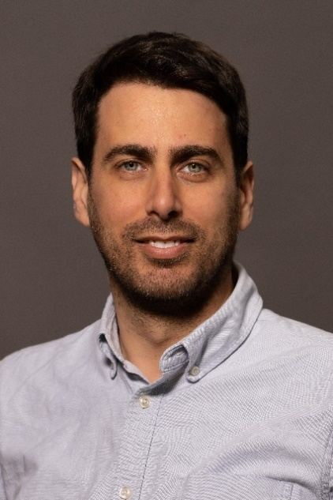

Americares Deputy Medical Officer Dr. Adam Schwartz provides medical oversight for all Americares health programs worldwide, ensuring evidence-based standards are integrated into clinical settings, Americares technical assistance programs, emergency programs, health system strengthening work and deliveries of medicine and medical supplies.
In addition to supporting Americares clinical and public health programs, Dr. Schwartz oversees a team that reviews donation offers from over 200 pharmaceutical and medical supply companies, confirming the products are suitable for Americares medicine security partners to use safely and effectively in low-resource settings. One of the world’s leading nonprofit providers of donated medicine and medical supplies, Americares distributes more than $1 billion in medicine and supplies to an average of 85 countries each year.
Dr. Schwartz is an attending primary care physician at Bellevue Hospital in New York City and an assistant professor at New York University’s School of Medicine.
Prior to joining Americares, Dr. Schwartz served in several roles at BRAC USA, including the health program director, where he collaborated with in-country teams to design, implement and evaluate public health projects in Sub-Saharan Africa and South Asia with a focus on community health workers, maternal and child health, infectious diseases, nutrition and family planning. He also co-directed BRAC USA’s global response to the COVID-19 pandemic.
Dr. Schwartz earned a bachelor’s degree in political and cultural elements of social change from Stanford University in California and a medical degree from Icahn School of Medicine at Mount Sinai in New York City. Board-certified in internal medicine, he completed his residency training at NewYork-Presbyterian/Weill Cornell Medical Center in New York City.

